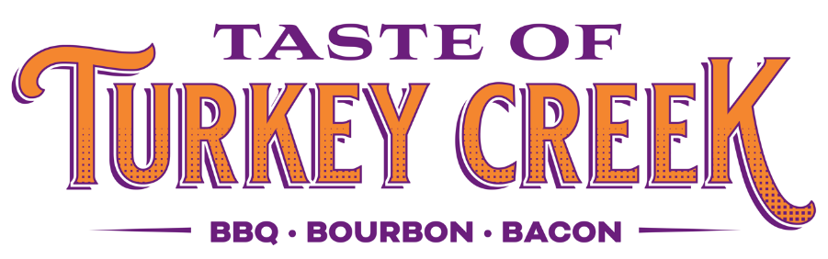

Pinnacle Turkey Creek | Taste of Turkey Creek 2022
October 8, 2022
6-9pm

Taste of Turkey Creek is Knoxville's premier tasting event. We are collaborating with the Pat Summitt Foundation to raise funds to fight against Alzheimer's disease. The 2022 Taste of Turkey Creek will host more than 20 local restaurants and offer craft beer, wine, and bourbon from Total Wine & More. This year’s Taste of Turkey Creek will offer a silent auction, kids' corner, and local vendors.
APPLICATION CHECKLIST
-Copy of Business License
-Photos for Advertising
-Application

The People's Choice Silver Knife Award is presented to the restaurant voted by the attendees of Taste of Turkey Creek. In 2017 we were happy to present Bonefish Grill with the "Silver Knife". They dished out their delicious "Saucy Shrimp" and it won the hearts of Taste of Turkey Creek attendees!
Runners-up included Season's Innovative Bar and Grill, Dickeys BBQ, and the Cutting Edge Classroom.
Advertising
We will use Instagram, Facebook, email newsletter, and our website to feature the event. Please submit photos you would like to have featured. Please include up to 5 images with your application for advertising purposes. We encourage all vendors to help cross-promote the event on their social media outlets.

Social Media Handle ___________________________________________________
Business Name _______________________________________________________
Contact Name ________________________________________________________
Address ____________________________________________________________
Phone ______________________________________________________________
Email ______________________________________________________________
Website ____________________________________________________________
Retailer Description ____________________________________________________
Brands/Products intended to sell: __________________________________________
___________________________________________________________________
INDEMNIFICATION & HOLD HARMLESS: By participating in the 2022 Taste of Turkey Creek, vendor hereby agrees to be individually and severally liable for and to indemnify and hold The Pinnacle at Turkey Creek, LLC., Crawford Square Real Estate Advisors, (collectively, the “Indemnitees”) harmless from and against any loss, personal injury, deaths, and/or any other damages, costs and expenses (including attorney's fees), liabilities, claims, or actions that may occur, be incurred by or be asserted against indemnitees as a result of the acts or omissions of vendors or that of its servants, agents, employees, customers, or invitees.
APPLICATION STATEMENT: I agree to abide by the terms of Taste of Turkey Creek outlined in the 2022 Application and Guidelines to obtain all applicable permits and licenses. Failure to abide by Rules will result in removal from 2022 Taste of Turkey Creek . I further agree not to hold any of the Indemnitees responsible for any damages arising out of the sales of my products.
This application shall in no way modify the provisions of the ‘Vendor Indemnification/Hold Harmless Agreement’ agreed to and signed by the undersigned.
SIGNATURE: _________________________ DATE: ______________________
PRINT NAME: ______________________________
Return form via mail or email to the address below to apply for the 2022 Yoga On the Green.

Gabi Abbatemarco, Marketing Associate
gabbatemarco@crawfordsq.com
@pinnacleatturkeycreek | www.Pinnacleatturkeycreek.com

Vendor Information
- Registration fee is $100 per vendor and includes a 10’ x 10’ tent along with (1) 8’ table and two (2) chairs.
- If additional space is needed, the vendor will have to purchase an additional space. Vendors are responsible for staffing, set up and breakdown of their booth.
- Electricity for booths is limited. Available electrical booth space will be assigned on a first come, first serve basis via registration. Vendors must bring their own drop cord(s).
- We do not offer exclusivity for any products or services nor do we guarantee you will not be placed near a competitor. We will work with each vendor as best as we can.
- ALL VENDORS WILL BE REQUIRED TO SHOW PROOF OF INSURANCE.
- We encourage vendors to set up on Friday, October 7 to avoid congestion and be rushed for time.
- Breakdown should be immediately at the end of the event, at 9 PM, when patros have cleared the event area. No early breakdown is allowed; vendors must commit to the entire event time (6pm-9pm).
- Event is rain or shine. All vendor fees are non-refundable.
- Food vendors utilizing any heat source must bring an appropriate fire extinguisher.
For more information, please contact Gabi Abbatemarco at gabbatemarco@crawfordsq.com

Vendor Registration (Please Fill Out and Return)

Name of Establishment: _________________________________________________
Email Address: ________________________________________________________
Day of Event Representative Name and Phone:_________________________________
___________________________________________________________________
Business Description: ___________________________________________________
Owner of Business/Phone: ________________________________________________
Electrical requirements (no guarantee, 120 volt ONLY)___________________________
Signature/Date: _______________________________________________________
Your signature agrees to terms above and to provide tastings to 1,500 guests, gratis in benefit of the Pat Summitt Foundation
The $100 fee includes
One 10’ x 10’ tent space with tent
One 8’ table
Two chairs
Application and certificate of insurance may be submitted electronically to gabbatemarco@crawfordsq.com

