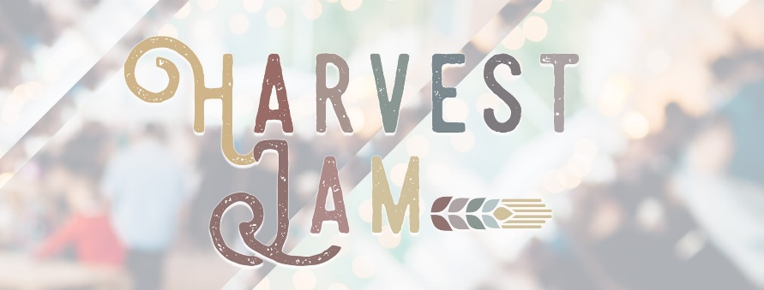

Pinnacle at Turkey Creek hosts a free, family-friendly event. Harvest Jam is October 1st from 11:00AM-2:00PM. This is an outdoor event with limited spots available. The event will take place in the Pavilion in between Loft and Talbots. Any vendors that will sell similar items or lines as our tenants will not be considered for a spot. Please attach the items listed below.
APPLICATION CHECKLIST

Copy Certificate of Insurance
Photos for Advertising
Application

APPLICATION DETAILS
All vendors must fill out the entire application and return it via email to gabbatemarco@crawfordsq.com. Pinnacle at Turkey Creek does have some restrictions due to the current tenant mix, therefore Pinnacle at Turkey Creek management may accept or deny applications. Accepted applicants will be notified regarding the status of their application within one week of submitting.
- All vendors are required to provide tables, linens, signage and any other items needed for the pop-up. Registration fee is $100 per vendor and includes a 10’ x 10’ tent. All vendors are responsible for set up and break down of space. Generators are allowed but must be silent.
Vendors must have a city of Knoxville business license and attach a copy with the application.

Advertising
We will use Instagram, Facebook, email newsletter, and our website to feature the event and our vendors. Please submit photos you would like to have featured. Please include up to 5 images with your application for advertising purposes. We encourage all vendors to help cross-promote the event on their social media outlets.

Social Media Handle ___________________________________________________
Business Name _______________________________________________________
Contact Name ________________________________________________________
Address ____________________________________________________________
Phone ______________________________________________________________
Email ______________________________________________________________
Website ____________________________________________________________
Retailer Description ____________________________________________________
Brands/Products intended to sell: __________________________________________
___________________________________________________________________
INDEMNIFICATION & HOLD HARMLESS: By participating in the 2022 Harvest Jam, vendor hereby agrees to be individually and severally liable for and to indemnify and hold The Pinnacle at Turkey Creek, LLC., Crawford Square Real Estate Advisors, (collectively, the “Indemnitees”) harmless from and against any loss, personal injury, deaths, and/or any other damages, costs and expenses (including attorney's fees), liabilities, claims, or actions that may occur, be incurred by or be asserted against indemnitees as a result of the acts or omissions of vendors or that of its servants, agents, employees, customers, or invitees.
APPLICATION STATEMENT: I agree to abide by the terms of Harvest Jam outlined in the 2022 Application and Guidelines to obtain all applicable permits and licenses. Failure to abide by Rules will result in removal from 2022 Harvest. I further agree not to hold any of the Indemnitees responsible for any damages arising out of the sales of my products.
This application shall in no way modify the provisions of the ‘Vendor Indemnification/Hold Harmless Agreement’ agreed to and signed by the undersigned.
SIGNATURE: _________________________ DATE: ______________________
PRINT NAME: ______________________________
Return form via mail or email to the address below to apply for the 2022 Harvest Jam. Please note, submission of application does not guarantee a presence at the Harvest Jam. Selected vendors will be notified by September 1st.

Gabi Abbatemarco, Marketing Associate
gabbatemarco@crawfordsq.com
@pinnacleatturkeycreek | www.Pinnacleatturkeycreek.com

